ML algorithms

Regression : Linear regression

Classification: Logistic regression

Decision Tree

Naive bayes

KNN

Support Vector Machine

Ensemble methods : Bagging(Random forest) and Boosting

Cluster algorithms: K-means

Hierarchical

Recommendation engine

Monday : we have python oops

End to end ML flask streamlit

Learning algorithms is different

Evaluation of algorithms

Supervised and unsupervised

Supervised : Regression and Classification

Regression: MSE

RMSE

MAE

RSE

R-sq

adjusted R-sq

MSE RMSE MAE MAPE

$classification metrics:$

$confusion matrix$

$accuracy$

$Error rate$

$Sensitivity=True postive rate$

$Specificity=True negative rate$

$Precision$

$Recall$

$F1 score$

$ROC-AUC$

$Kohens-kappa$

$confusion matrix:$

$assume that target variable has two classes or two labels : yes no$

$Model also predicts either yes and no$

$actual labels (yes or no) and model prediction (yes or no)$

$actual output yes, model can predict either yes or no$

$True postives (TP):actually yes, model predicted as yes$

$False negative (FN):actually yes, model predicted as no$

$False postives (FP):actually no, model predicted as yes$

$True negative (TN):actually no, model predicted as no$

$TP====second l P===model is predicting yes, and it is correct$

$FP====second P====model ispred yes, it is wrong$

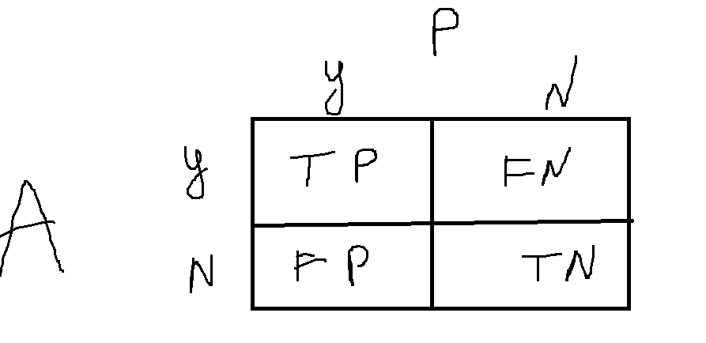

| y | Y_predictions | TP/TN/FP/FN |
| --- | --- | --- |
| Yes | No | FN |
| Yes | Yes | TP |
| Yes | Yes | TP |
| No | Yes | FP |
| No | No | TN |
| Yes | No | FN |

P

|  | Yes | No |
| --- | --- | --- |
| Yes | TP=2 | FN=2 |
| No | FP=1 | TN=1 |

| y | Y_predictions | TP/TN/FP/FN |
| --- | --- | --- |
| Yes | No |  |
| Yes | NO |  |
| Yes | No |  |
| No | Yes | FP |
| No | Yes |  |
| NO | Yes |  |

| **Classes** | **Yes** | **No** | **Total** | **Recognition** |
| --- | --- | --- | --- | --- |
| Yes  No | 90  140 | 210  9560 | 300  9700 | 30.00%  98.56% |
| Total | 230 | 9770 | 10,000 | 96.40 |

Precision recall accuracy

$Precision=\frac{TP}{TP+FP}=\frac{90}{90+140}=\frac{90}{230}=0.39≅0.4=40\%$

$Recall=\frac{TP}{TP+FN}=\frac{90}{90+210}=\frac{90}{300}=0.30=30\%$

$Precision=40\%$

$model is predicting 40 out of 100 actuals$

$Recall=30\%$

$out of 100 actual postives , model is predicting 30 are correctly$

$accuracy=96\%$

$Precision=\frac{TP}{TP+FP}$

$Recall=\frac{TP}{TP+FN}$

$Precision and recall Nr=TP$

$FP vs FN$

$FP:actually no, model is predicted as yes$

$ambani went to DMART, ambani is not a terrosist, model is predicting as terrorist$

$FN:actually yes, model is predicted as no$

$a terrorist went to DMART, model is predicting as not terrorist$

$precsion and recall importance vary according to problem statement$

$but most of the time , recall consider as important$

$suppose DT P=80\% R=85\%$

$KNN p=85\% R=80\%$

$NB P=81\% R=84\%$

$F1 score=\frac{2*Precision*Recall}{Precision+Recall}$

$AM=\frac{a+b}{2};GM=root\left(ab\right);HM=\frac{2ab}{a+b}$

$accuracy=\frac{Tp+Tn}{Tp+Fp+Fn+Tn}$

$Error rate=1-accuracy$

$TPR=\frac{TP}{P}$

$TNR=\frac{TN}{N}$

$Precision=\frac{TP}{TP+FP}$

$Recall=\frac{TP}{TP+FN}$

$F1 score=\frac{2*P*R}{P+R}$